**TECHNICAL REPORT ON HOTEL RESERVATION AND CANCELLATION INSIGHTS (2015 – 2017).**

**Introduction.**

The purpose of this report is to present a detailed analysis reservation and cancellation insights of the Resort and City hotel, how waiting days affect hotel booking cancellation, compare reservation status between City Hotel and Resort Hotel. Also, the best customers for the year, reservation trend, its fluctuations and provide insights and actionable recommendations that will improve booking and avoid excess cancellations.

**Story of the data**

The data is obtained from a public dataset and tells a story around hotel reservation and cancellation of bookings and how this cancellation affect revenue generation and possible causes of this cancellation.

**Data Collection Process:** This data is obtained from a public source.

**Data Structure:** The data is arranged with columns representing Hotel, Adults, Children, Babies, Meal, Country, Name, Cancelled, Lead time, Arrival date year, Arrival date month, Arrival date week number, Arrival date of month, Stay in weeks night, Market segment, Distribution channel, Repeated guest,Previous cancellation, Previous booking not cancel, Reserve room type, Assign room type, Booking changes, Deposit type, Agent, Company, Days in waiting list, Customer type, Adr, Required car packing space, Total of special request, Reservation status, Reservation status date, Email, Phone number, Credit card and finally rows representing both the City Hotel and Resort Hotel.

**Data Splitting and Preprocessing.**

**Data Split:** The data was split into two categories. Category one is the Independent variables while category two is the dependent variables.

**Category One - Independent variables**

Hotel, Adults, Children, Babies, Meal, Country, Name.

**Category Two - Dependent values**

Hotel, Adults, Children, Babies, Meal, Country, Name, Cancelled, Lead time, Arrival date year, Arrival date month, Arrival date week number, Arrival date of month, Stay in weeks night, Market segment, Distribution channel, Repeated guest,Previous cancellation, Previous booking not cancel, Reserve room type, Assign room type, Booking changes, Deposit type, Agent, Company, Days in waiting list, Customer type, Adr, Required car packing space, Total of special request, Reservation status, Reservation status date, Email, Phone number, Credit card.

**Industry context:** The Data is telling a story around Hotel reservation and cancellation and how cancellation of bookings can affect revenue generation.

**Stakeholders:** Director, Line Managers and Supervisors.

**Value to the Industry:** The insights will help City and Resort Hotels know the possible causes of booking cancellation, and how to minimize booking cancellation and generate more revenue.

**Pre-Analysis**

**Questions**

* Customers performance Analysis based on numbers of days lodge.
* Sum of cancelled days by Country.
* Reservation status of each Hotel.
* Countries with highest booking rate.
* Countries with the highest cancellation rate.
* Trend Report.

**Observations:**

* William Smith has made the highest number of bookings with 137 bookings within this period.
* Portugal (PRT) leads with 48,590 reservations.
* City Hotel has the most cancellations (33,102), accounting for 75% of total cancellations.
* City Hotel also has the highest reservations with 146,838 while 74,798 for Resort Hotel.
* Peak bookings occurred around August and cancellations follow a consistent pattern.
* The Top 6 customers that contributed a significant volume of bookings are William Smith, Robert Smith, Michael Johnson, John Smith, Christopher Smith and Michael Smith.
* Portugal has the highest number of cancellations (27,519), which may correlate with its high booking volume.
* Peaks are seen in July and August, suggesting overbooking or capacity issues during these months.

**Recommendations:**

* Develop loyalty incentives for high-value customers like William Smith to encourage repeated stays.
* Investigate cancellation reasons for City Hotel and Portugal-based bookings. Introduce flexible booking options or cancellation penalties.
* Use seasonal trends e.g., peak in August to adjust staffing.
* Increase promotions in underperforming countries e.g., DEU, ESP
* January and September need better planning to reduce waiting times.
* Relying heavily on a few top customers or countries introduces risk.
* City Hotel dominates in both bookings and cancellations. Consider promotions or upgrades for the Resort Hotel to boost its performance.

**Data Visualization and Charts.**

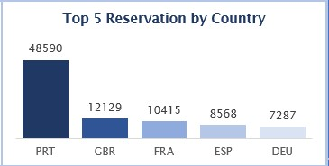

The column chart shows top 5 reservation by country and the numbers each country has reserved within 2015 - 2017. The top on the list is Portugal with 48,590 reservations while the least is Deutschland with 7,287 reservations.

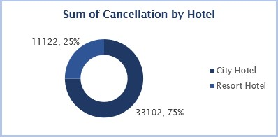

The highest cancellation is City Hotel with a total cancellation of 33,102 between 2015 – 2017 and resulting to 75% cancellations while the Resort Hotel has a total of 11,122 cancellation and resulting 25% cancellations.

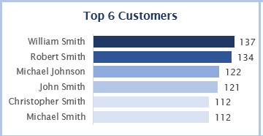

The bar chart shows the top 6 customers for both City and Resort Hotel between 2015 – 2017. The chart shows that William Smith is the best customer with a total of 137 reservations.

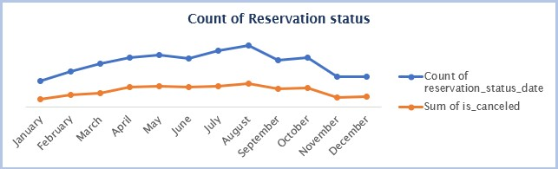

The reservation status trend shows that the peak occurs in July and August which also correlate to the high number of booking during this period for both City and Resort Hotel.

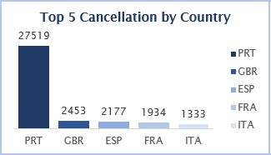

The chart shows cancellation by country with Portugal having the highest cancellation of 27,519. This shows why Portugal has the highest reservation by country.

**DASHBOARD**

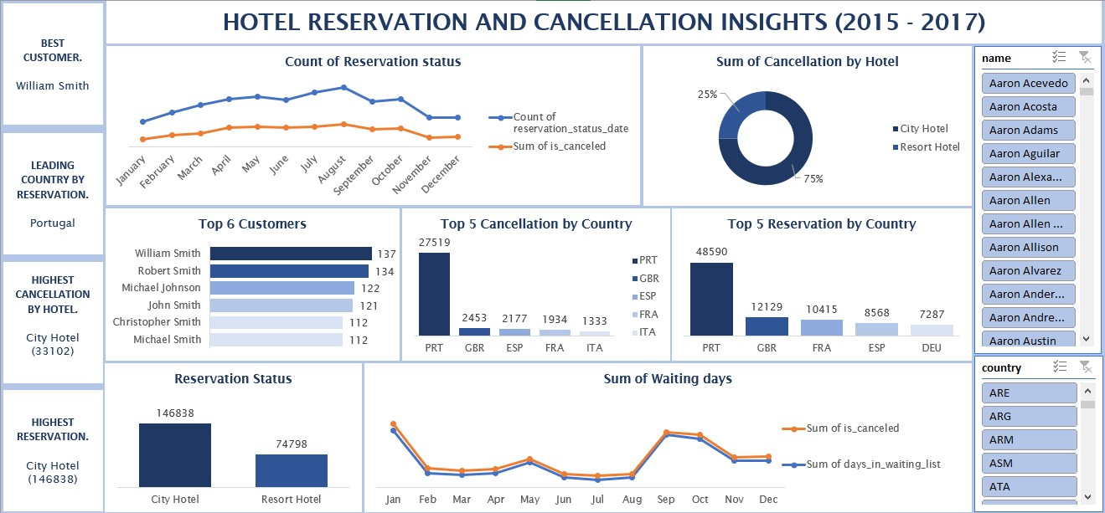

**Final Recommendations.**

1. Treat loyal customers like William Smith to VIP treatment.

2. Since Portugal contributes the highest volume of bookings and cancellations, hotels should Offer flexible booking or refund policy for Portugal target.

3. Run localized marketing campaigns in high reservation areas.

4. Investigate causes of high cancellation rates at City Hotel, particularly during peak months.

5. Improve customer service to avoid high rate of cancellations.

6. Strengthen staff and resource allocation during July–October to manage high reservation and cancellation volumes.

7. Consider pricing, discount, and special packages during off-peak months.

**Conclusions:**

1. William Smith is the best customer with 137 reservations.

2. Portugal has the highest reservation with 48,590 reservations leading all other countries. It also has the highest cancellation with 27,519.

3. Cancellations peak is around August and September, which is as a result of overbooking, or poor customer service during this period.

4. The sum of waiting days is highest in January and September, aligning with cancellation peaks and high reservation demand.